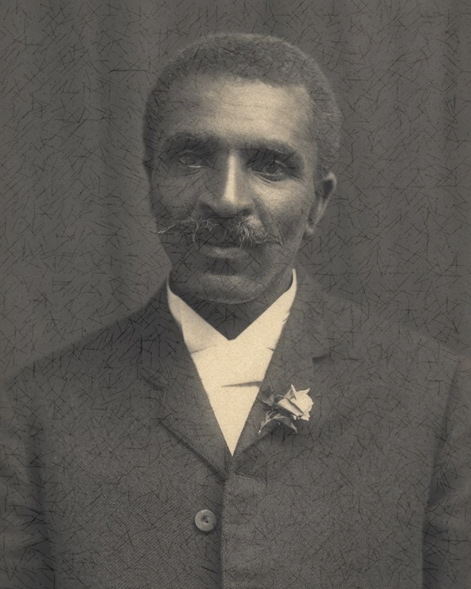
“Speak to the earth, and it will instruct you.” ~Job 12:8a
As a teenager, I read a biography of George Washington Carver from the Sower Series. It was a truly inspirational tale. He overcame developmental delays and the racial discrimination of the times. The man was a genius who humbly devoted himself to God by helping others.
After years of depending on cotton as its primary crop, the South’s soil was depleted. This coupled with a boll weevil infestation was causing no little amount of hardship for farmers. As head of the agricultural department of the Tuskegee Institute in Alabama, George wanted to help, so he prayed that God would show him what to do. One of his favorite passages of Scripture from the Bible was Job 12:7-8. He followed that advice.
There is a quote which has been attributed to Albert Einstein, it says, “Insanity is doing the same thing over and over again and expecting a different result.” How many times do we do that exact thing? Like the farmers in the South planting the same crop over and over without replenishing the soil, we do the same things, we make the same mistakes, sin the same sins, without repenting. Acts 3:19 says, “Repent, then, and turn to God, so that your sins may be wiped out, that times of refreshing may come from the Lord,”
Mr. Carver knew how to find the truth. He knew that in order to help others, in order to make a difference, things needed to change. He knew to turn to God and His word for inspiration. If your life seems to be depleted, if you haven’t been replenishing the soil of your heart and life, then perhaps it’s time that you repent, turn to God, and allow Him to fill you once again.

