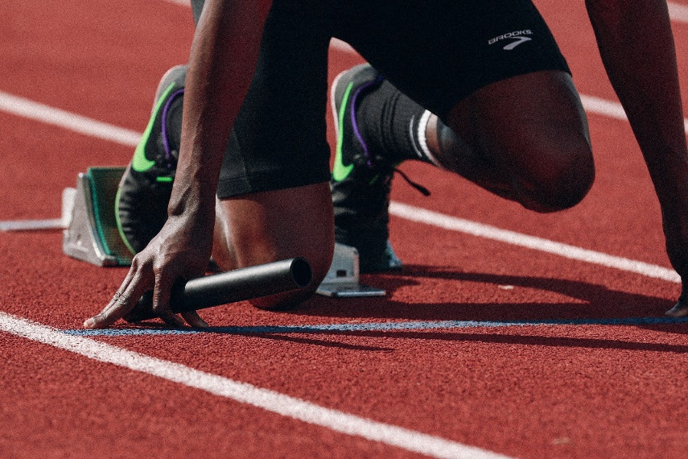
“Don’t you realize that in a race everyone runs, but only one person gets the prize? So run to win! All athletes are disciplined in their training. They do it to win a prize that will fade away, but we do it for an eternal prize. So I run with purpose in every step. I am not just shadowboxing. I discipline my body like an athlete, training it to do what it should. Otherwise, I fear that after preaching to others I myself might be disqualified.” ~1 Cor. 9:24-27
I went to work yesterday. That might not seem like a big deal, but I haven’t been there in a month. The last time I was at work, I couldn’t catch my breath. It felt as though I was running a race for which I hadn’t trained. It turns out, I was dangerously low on hemoglobin. I didn’t have enough to adequately carry oxygen through my body. I didn’t have the tools I needed for the task set before me.
We are encouraged to train. To run the race to completion. Many of us though have not prepared. We don’t have the tools that we need to finish the race, to fight the fight, so, we falter or give up altogether.
When I came back to work, I marveled at how much better I felt. It dawned on me that I had been feeling worse and worse as time went on. That last day had simply been the final straw.
How are you feeling? Are you running the race at your peak or are you barely coasting on fumes? Go to God. Let Him help you with your training. Let him fill you and give you all you need to run strong!
“No discipline is enjoyable while it is happening—it’s painful! But afterward there will be a peaceful harvest of right living for those who are trained in this way. So take a new grip with your tired hands and strengthen your weak knees. Mark out a straight path for your feet so that those who are weak and lame will not fall but become strong.” ~Heb. 12:11-13

