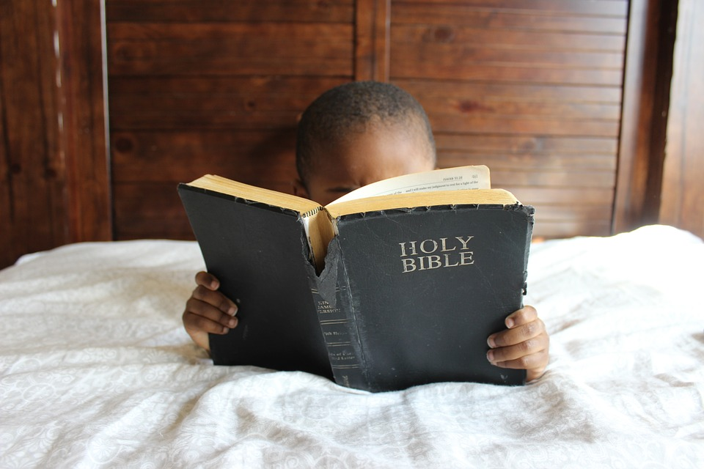
“Train up a child in the way he should go, Even when he is old he will not depart from it.” ~Proverbs 22:6
This verse speaks of ‘training up’ a child. It uses the same words that are used to describe guiding a vine to grow in the proper direction. We have black raspberries at the corner of our property. For those of you who don’t know it, these vines will spread everywhere if not properly pruned and guided! In the same way, God admonishes us to guide our children in the way that they should go. Without proper guidance they will grow in directions they shouldn’t. We don’t expect our plants to simply watch their parent plants for cues as to how and in which direction to grow; we shouldn’t expect our children to either.

