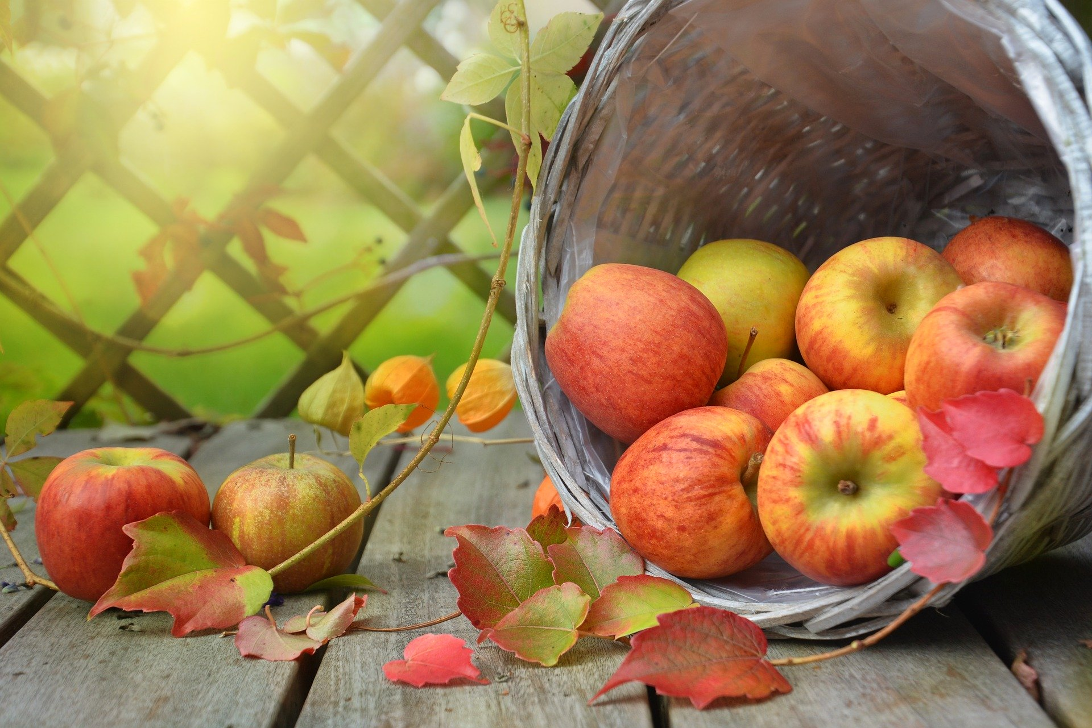
“I will offer you a sacrifice of thanksgiving and call on the name of the LORD.” ~Psalm 116:17

It’s not often that we think of being thankful as a sacrifice, or at least not often that we will admit it. There are times when we must truly work at being thankful. Times when being thankful is the last thing on our minds.
Whether we are at the point in our lives where we are believing in faith that we have received an as yet unfulfilled prayer, or we are looking back or around in great thankfulness at all our blessings, we all have reason to be thankful. Sometimes our circumstances make thanksgiving a sacrifice, but that doesn’t mean that we are exempt from being thankful. Do you have a home? Be thankful. Do you have a means of transportation? Be thankful. Do you have family? Be thankful. Did you wake up this morning? Be thankful; you have been given one more day or one more hour, even one more moment to make a difference for God’s kingdom.
No matter where you are in life, show your gratefulness to the Lord. In this season of Thanksgiving offer your sacrifice of thanksgiving. What are you thankful for?

