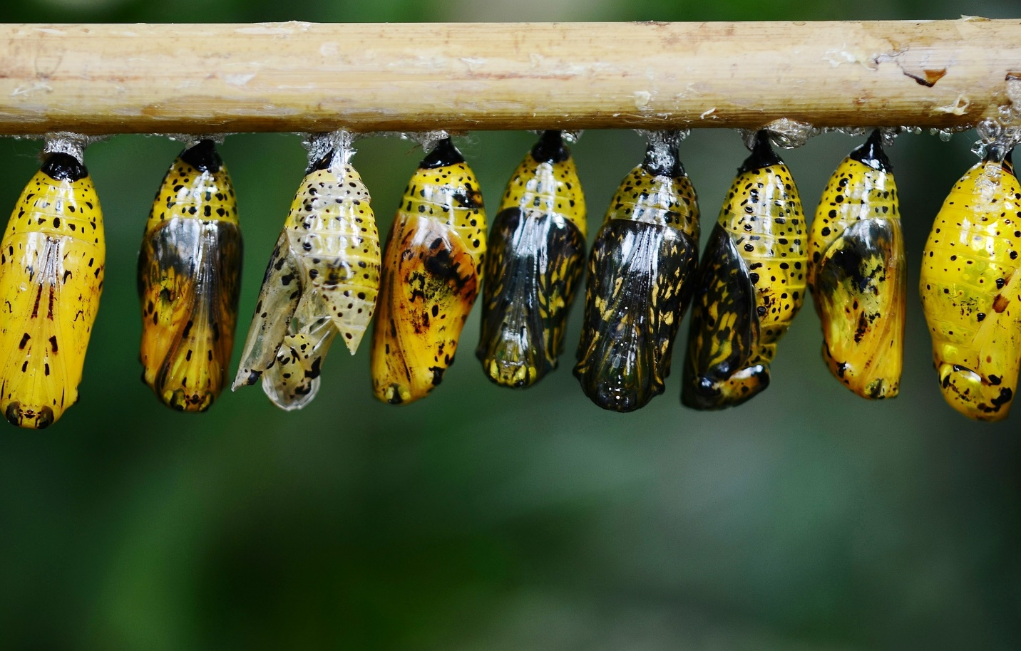
Did you know that if you ‘help’ a butterfly to emerge from its cocoon that it will die, or at least never develop to its true potential? The struggle to break free is what helps the butterfly become what it was always meant to be. Pushing its way through the tiny tear in the cocoon is what forces the fluids out of its body and into its wings. Without the struggle, the butterfly will never fly. It will remain swollen and stunted.
Today many seek to create a life that is lived inside of a bubble. They want a world where they are never faced with challenges or struggles. They want ‘safe zones’. If you look at the great men and women of history you will likely see adversity in their lives, things that they had to overcome. Look at George Washington Carver, Teddy Roosevelt, Rosa Parks, Joseph, Esther, Jesus. Without their struggles, we would never know their names. Instead of running from the battle, make sure that you are equipped for the fight.
“A final word: Be strong in the Lord and in his mighty power. Put on all of God’s armor so that you will be able to stand firm against all strategies of the devil. For we are not fighting against flesh-and-blood enemies, but against evil rulers and authorities of the unseen world, against mighty powers in this dark world, and against evil spirits in the heavenly places.
“Therefore, put on every piece of God’s armor so you will be able to resist the enemy in the time of evil. Then after the battle you will still be standing firm. Stand your ground, putting on the belt of truth and the body armor of God’s righteousness. For shoes, put on the peace that comes from the Good News so that you will be fully prepared. In addition to all of these, hold up the shield of faith to stop the fiery arrows of the devil. Put on salvation as your helmet, and take the sword of the Spirit, which is the word of God.
“Pray in the Spirit at all times and on every occasion. Stay alert and be persistent in your prayers for all believers everywhere.” ~Ephesians 6:10-18

