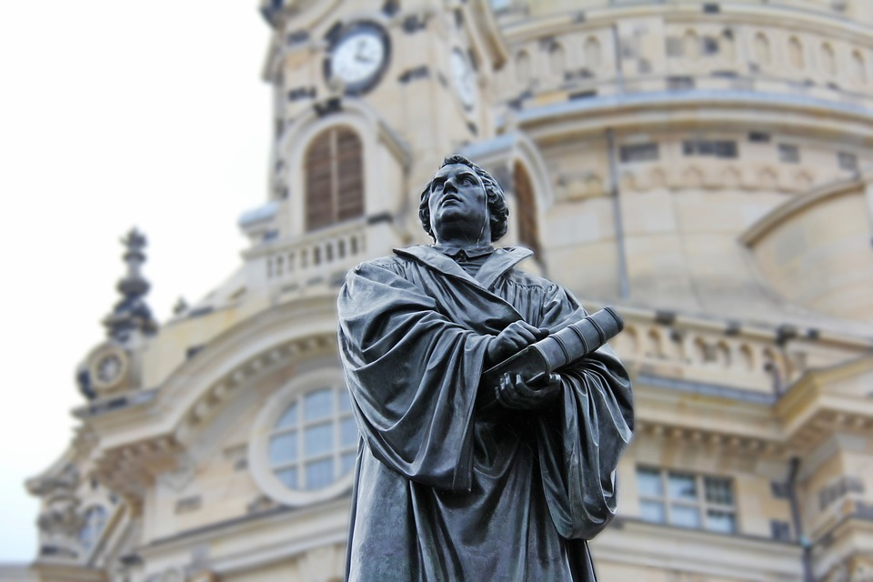
“For there is one God, and one mediator between God and men, the man Christ Jesus;”~1 Timothy 2:5
On October 31st, 1517 Martin Luther nailed his Ninety-five Theses to the door of a chapel in Wittenberg, Germany. He saw corruption and greed all about him. He saw the church bowing to the ways of the world. He earnestly and sincerely wanted them to see that what they were teaching didn’t line up with Scripture. He wasn’t condemning them; he was trying to shine a light on the right path; to show them the way. He even used the technology of the day, the printing press, to spread the word.
The world around us is corrupt and greed abounds. It is calling black white and white black. Even the church is beginning to bow to the ways of the world; saying that our philosophies and beliefs need to change with the times. Scripture tells us that, “What has been will be again, what has been done will be done again; there is nothing new under the sun.”(Ecc. 1:9) In other words, times don’t change. Since this is the case, we can clearly see that the rules and guidelines for Christianity set forth by Jesus are not things which should be fluid and changing; tossed by the waves of public opinion. They are solid and timeless, steady and unwavering.
If our leaders, “the apostles, the prophets, the evangelists, and the pastors and teachers” live up to, “their responsibility,” which, “is to equip God’s people to do his work and build up the church, the body of Christ...until we all come to such unity in our faith and knowledge of God’s Son that we will be mature in the Lord, measuring up to the full and complete standard of Christ.
Then we will no longer be immature like children. We won’t be tossed and blown about by every wind of new teaching. We will not be influenced when people try to trick us with lies so clever they sound like the truth. Instead, we will speak the truth in love,” (taken from Eph. 4)
So let’s make sure that our leaders are ones who will teach us the truth, that way we won’t be “tossed and blown about by every wind of new teaching”. Then we can “speak the truth in love”, even using the technology of the day to do it.

