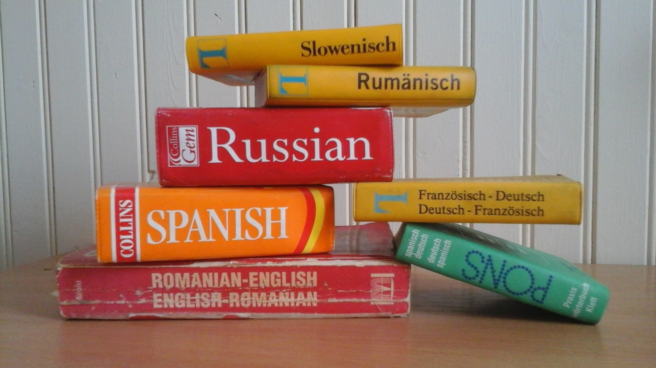
“I am writing to God’s chosen people who are living as foreigners in the provinces of Pontus, Galatia, Cappadocia, Asia, and Bithynia. God the Father knew you and chose you long ago, and his Spirit has made you holy. As a result, you have obeyed him and have been cleansed by the blood of Jesus Christ.” ~1 Peter 1:1-2

A person who owes allegiance to a foreign country is considered a foreigner. It’s someone who lives one place but considers another place their home. Later, in the book of 1 Peter, it refers to them as strangers. In a very real sense, we as Christians are both to the world around us. Our ways are different; our speech is strange; we just don’t fit in.
It’s different than a homesteader. A homesteader is someone who acquires land with the purpose of establishing their home and life there. Sometimes we get tired of being different, of being foreigners. We may be tempted to try to blend in with those around us; to act the way they act or speak the way they do; to consider this our home. We aren’t called to that though. We are called to ‘live properly among (y)our unbelieving neighbors.’ (1 Peter 2:12)
We have a priceless inheritance (1 Peter 1:4), we shouldn’t settle for anything less that we find in the world around us. It’s your decision. Will you be a foreigner or a homesteader?

