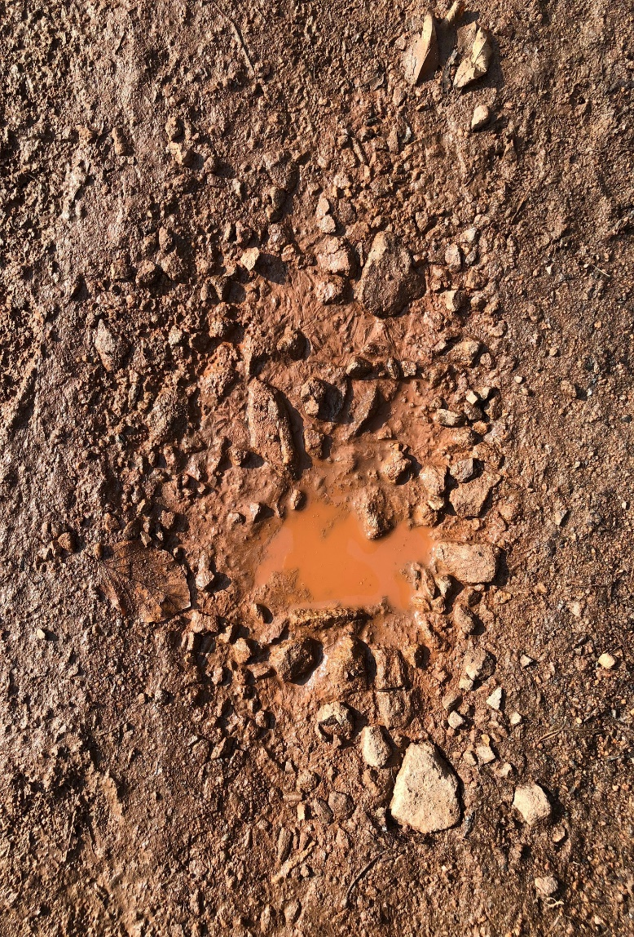
“So what makes us think we can escape if we ignore this great salvation that was first announced by the Lord Jesus himself and then delivered to us by those who heard him speak?” ~ Hebrews 2:3
“For my people have done two evil things: They have abandoned me—the fountain of living water. And they have dug for themselves cracked cisterns that can hold no water at all!” ~Jeremiah 2:13

I love it when I can see God speaking; it happened yesterday. The first verse came up in our Sunday school class and the second came during the sermon, each led by different people who did not confer with one another ahead of time. It’s a confirmation that this message is important.
I want to admit something, my approach to unpleasant things is to ignore them and hope they go away. If we don’t have the money to pay a bill, I ignore it. If the family room looks like a cyclone hit it, I ignore it. If a relationship isn’t going well, I ignore it. I’m not saying it’s a good strategy; I’m just saying that tends to be how I handle things.
How many times do we see people who have ignored salvation? They’ve heard about it, but they’ve put off the decision, or worse yet, they’ve abandoned that precious spring in favor of dirty water that they can barely hold onto. The Bible calls this evil and lets us know that, just like those bills, you can’t escape the consequences by ignoring it.
There will be a day of reckoning, a day where each one of us is called to account. What will you say when asked? Don’t ignore Jesus’ salvation; you can’t be refreshed by dirty water.

