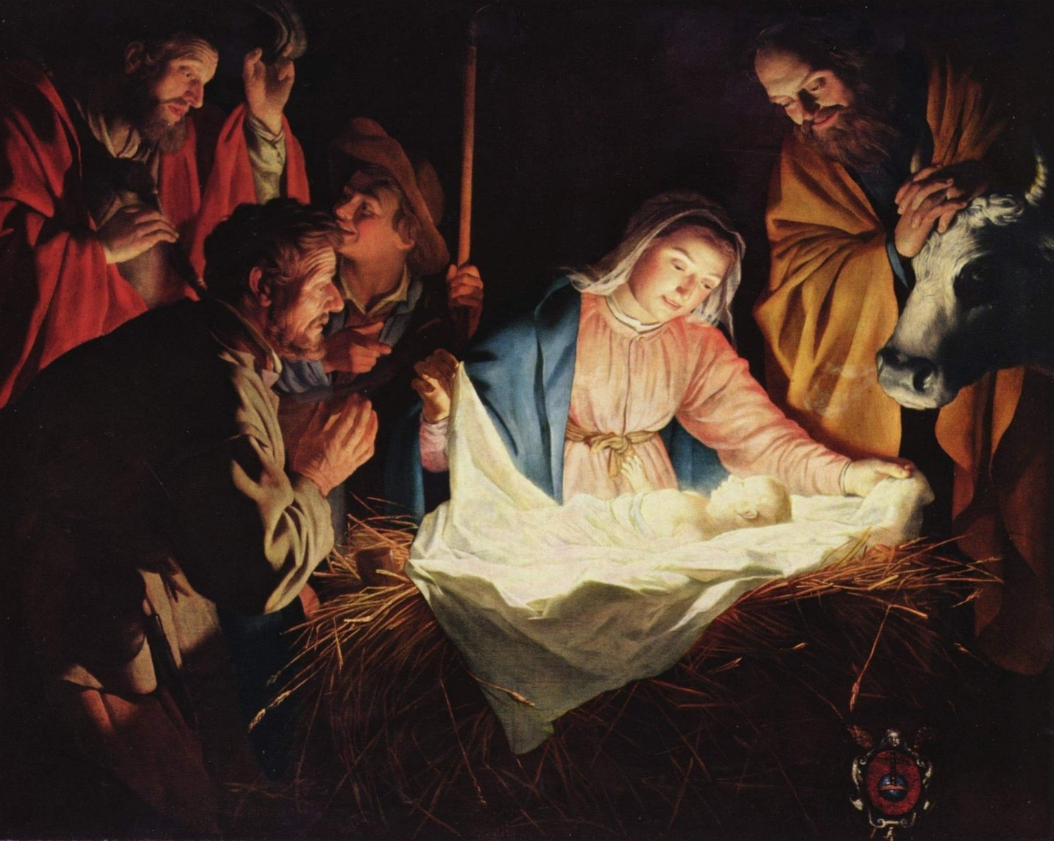
“In your relationships with one another, have the same mindset as Christ Jesus”
~Philippians 2:5

At Christmastime, it’s nice to think about wise men on camels, about a star, and about a baby lying in a manger. The magic of the season gives us a warm glow, but do you stop to think about what the true meaning of Christmas is? Christmas is about the ultimate sacrifice.
In our own lives, how many times have we wished that things could be better? We long for our health to be restored. We yearn for love and belonging. We crave stability. Jesus had all of those things. He had never known sickness or weakness. He knew his place in the universe. He had everything, but he gave it all up for us. For our sakes, he came into a world where he would know pain and suffering. He became a human who would experience both the love of dear friends and their betrayal. He went from having the Earth as his footstool to having nowhere to lay his head.
Jesus admonishes us to have the same mindset with one another as he did. We are to love each other just as much as he loved us. So, as you look at that baby in the manger this Christmas season, remember to take the true message of Christmas with you all through the year.

