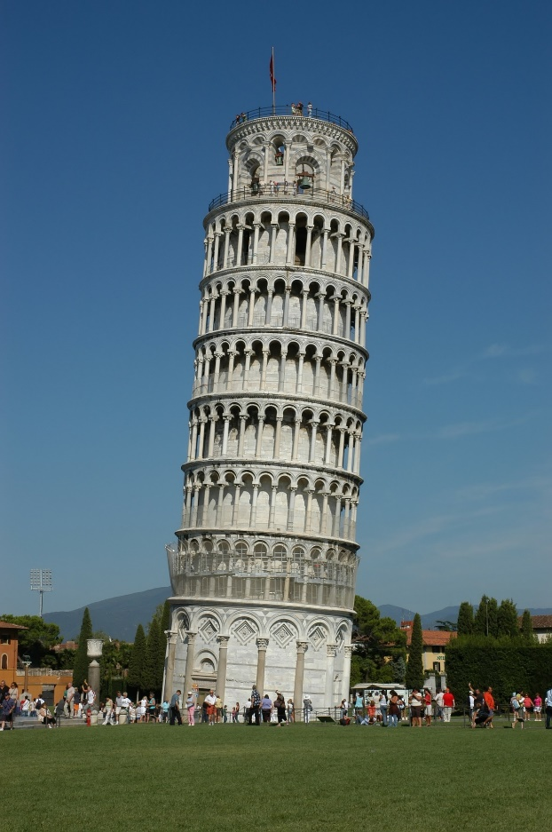
“Study to shew thyself approved unto God,” ~2 Timothy 2:15 KJV

There is a famous tower in Italy that was built on a foundation of clay, sand, and shells instead of bedrock. As a result of its shoddy foundation, partway through its construction, the tower began to lean. Instead of halting construction completely, engineers decided to try to ‘fix’ the problem. They worked on the building itself, ignoring the foundation. As a result, the tower continued leaning ever more precariously until it was in danger of collapse.
Some of us rely solely on what other people tell us that the Scriptures say, without studying them for ourselves. If we do that, we can easily be led astray. We will have no idea what the Bible really says. Our foundations will be nothing but sand.
Sand is easily blown whichever way the winds of change decide. The rock of God’s Word is unchangeable. It is solid and stable. Which would you rather build your life upon?

