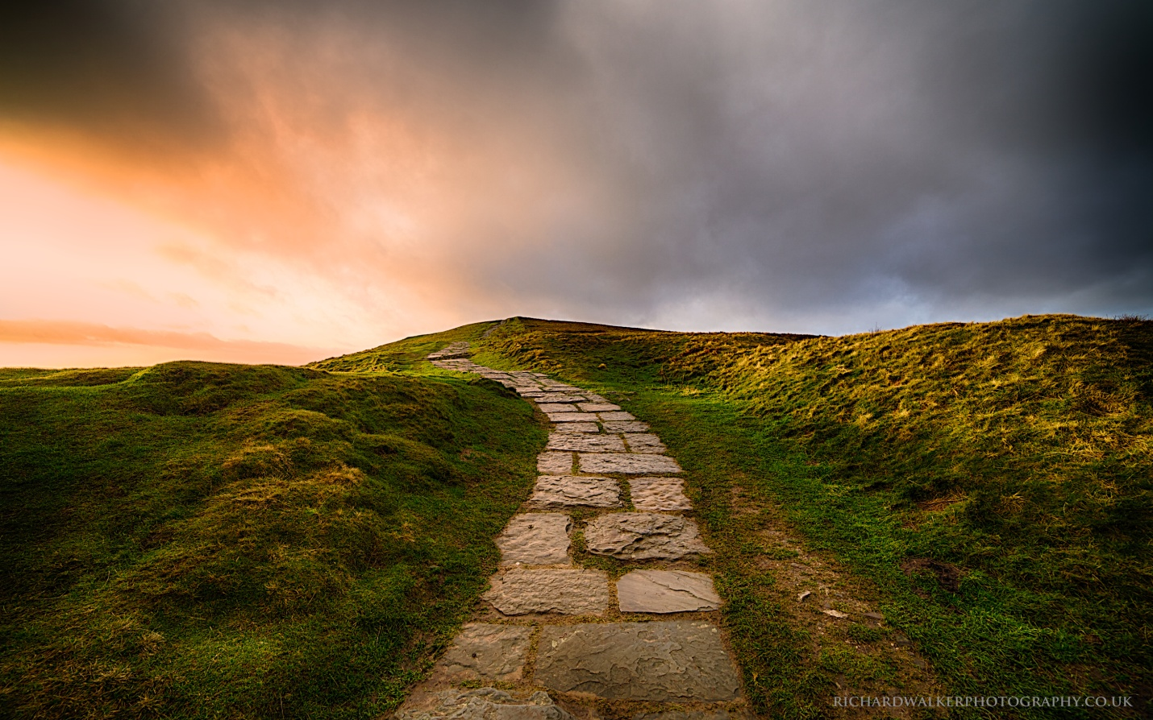
(www.richardwalkerphotography.co.uk)
“Sinners will have no place among the godly. For the LORD watches over the path of the godly, but the path of the wicked leads to destruction.”~Psalm 1:5b-6
“Jesus told him, “I am the way, the truth, and the life. No one can come to the Father except through me.” ~John 14:6
Have you ever heard people touting the ‘many paths to god’? I agree that there are many paths to god, but only one path to God. In fact Jesus tells us in Matthew 7:13b that, “The highway to hell is broad and its gate is wide for the many who choose that way.” The Lord clearly states in Psalm 1 that there is no place for sinners among the godly.
On the flip side Jesus tells us that, “The gateway to life is very narrow and the road is difficult, and only a few ever find it.” I think so few ever find it because they aren’t truly looking. There are signposts pointing the way all through the Bible. Just check out Romans 10, 1 Timothy 2, John 3:16, the list goes on and on.
Which path will you choose?

