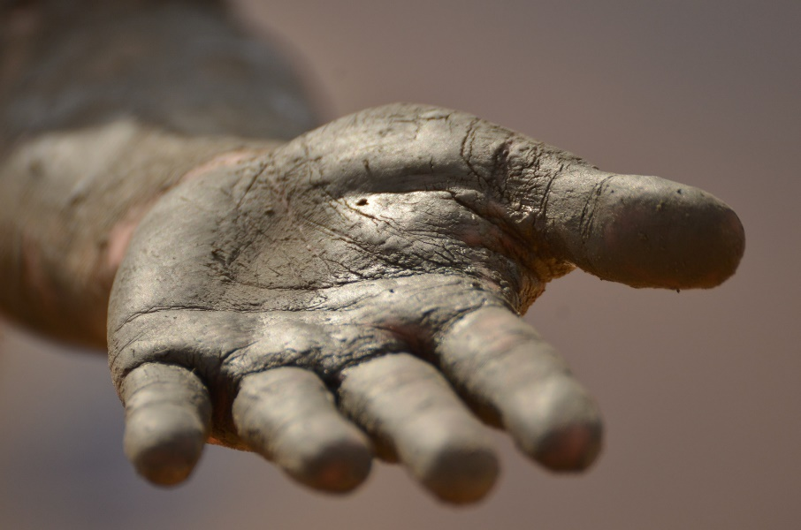
“So he went to Zarephath. As he arrived at the gates of the village, he saw a widow gathering sticks, and he asked her, “Would you please bring me a little water in a cup?” As she was going to get it, he called to her, “Bring me a bite of bread, too.”
But she said, “I swear by the LORD your God that I don’t have a single piece of bread in the house. And I have only a handful of flour left in the jar and a little cooking oil in the bottom of the jug. I was just gathering a few sticks to cook this last meal, and then my son and I will die.”
But Elijah said to her, “Don’t be afraid! Go ahead and do just what you’ve said, but make a little bread for me first. Then use what’s left to prepare a meal for yourself and your son. For this is what the LORD, the God of Israel, says: There will always be flour and olive oil left in your containers until the time when the LORD sends rain and the crops grow again!”
So she did as Elijah said, and she and Elijah and her family continued to eat for many days. There was always enough flour and olive oil left in the containers, just as the LORD had promised through Elijah.” ~1 Kings 17:10-16

This woman was at the end of her rope. She obviously knew God because, in verse 9, God says that he instructed her to feed Elijah. She had probably cried out to God multiple times to help her save her child. As a mother, I can only imagine the despair she felt in knowing that she was about to fix the final meal for her son before they both starved to death.
Although things have never been quite that desperate for us, I can relate to this woman. We are not rich by any means. We have scrimped and saved and struggled for everything we have. Even now, we face the seemingly overwhelming expenses of college looming over our heads. We’ve tightened our belts so many times; it seems we’ll need to punch a few more holes in the leather!
Sometimes we feel as if there is no hope left for us. We barely have enough in us to sustain ourselves, let alone bless others. But God doesn’t call us to focus on our own needs; he calls us to reach out. He calls us to be a blessing. Don’t miss out on the opportunity to bless others whom God puts in your path. Go ahead, be a blessing.

