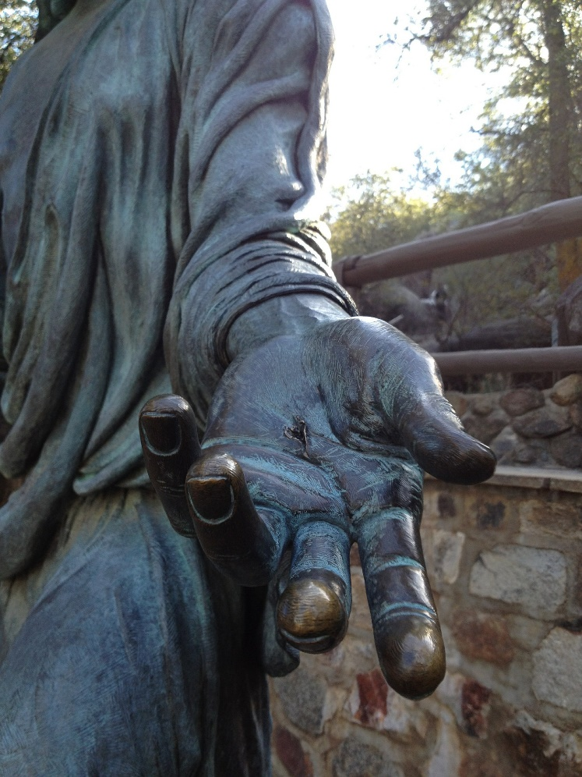
In a recent sermon, our pastor wrote the heading, “We need to live for the applause of the nail-scarred hands.” I was so moved by that profound statement. Whose approval am I living for?
It is so easy to get caught up in seeking our validation from the world. We feel that we must be the best at something. We cannot simply be a wife and mother, or the person helping out on Sundays in children’s church. Just attending a midweek service can’t be all that important, right? Yet the scriptures equate the comfort that the Lord provides with that provided by a mother (Isaiah 66:13). Those helpers in the children’s church may not get official recognition, but any child knows that they are important. How many of us came to know the Lord as a child, perhaps as a direct result of a children’s church or Sunday school worker? As for simply attending a midweek service, well what about that person whom you helped to encourage? We are told in Hebrews 3:13 to, “encourage one another daily, as long as it is called ‘Today,’”
You may never know the full impact of your life here on earth, and that’s all right. We aren’t living for the applause of men, but for the applause of the nail-scarred hands.

