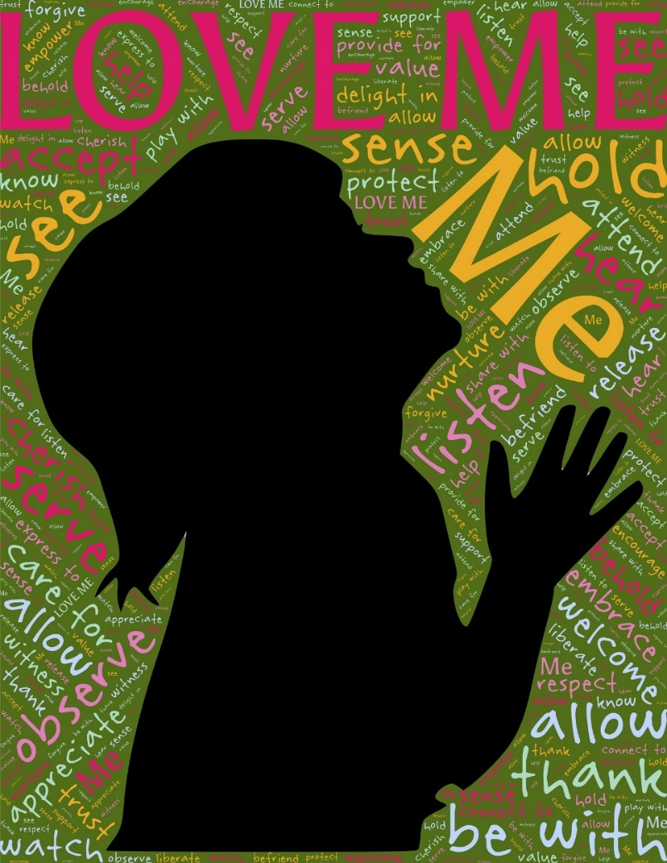
“when you believed in Christ, he identified you as his own” ~found in Ephesians 1:13

We have a choice. God had planned from the beginning of time that we would be His children, adopted into His family, but we have a choice in the matter. He doesn’t force us. He has wonderful things planned for us, but we must choose. We must reach out and accept the gift that He offers.
It’s hard to imagine someone deciding to reject God’s gift. Imagine living in squalor and having the king offer to adopt you into his family. You would have all the advantages of being a child of royalty and everything that entails. Now imagine turning your back on that offer, saying, ‘No thanks, I think I’ll continue living in this cardboard box and eating out of the dumpster.’ Really?
We have a choice. God loves you and wants to adopt you into His family. You could be a child of the King. All you have to do is take that first step and accept it. What are you waiting for?

